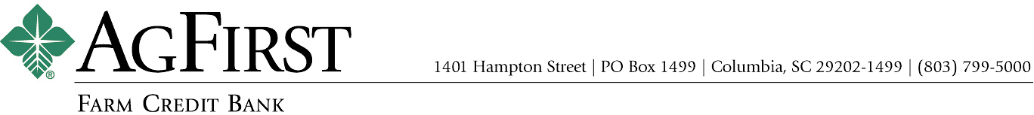

NEWS RELEASE Contacts:
Donna J. Camacho, Director of Communications
dcamacho@agfirst.com; 803-753-2251
Joy M. Upchurch, Vice President-Marketing
jupchurch@agfirst.com; 803-753-2379

for release
Friday, August 22, 2003

AgFirst announces Second Quarter Financial Results
Net income continues positive trend

Columbia, S.C. — AgFirst Farm Credit Bank reported today that its net income for the six months ended June 30, 2003, was $96.7 million, a 2.26 percent increase from the $94.6 million reported for the same period a year ago. Several factors contributed to the higher earnings, including increased loan volume, lower debt costs, and increases in fee and other income.
“We have continued to manage our debt portfolio in this low interest rate environment to reduce our debt costs and increase our net interest margins,” said AgFirst CEO F. A. (Andy) Lowrey. The bank has taken advantage of this year’s lower interest rates by refinancing the notes and bonds it issues to fund agricultural loans and mortgages. “While our loan volume increased 6.39 percent from June 30, 2002 to June 30, 2003, our interest expense decreased 25 percent and our net interest income increased more than 6 percent,” Lowrey added.
AgFirst provides funding and financial services to 24 Farm Credit associations in 15 eastern states and Puerto Rico. These associations provide real estate and production financing to more than 80,000 farmers, agribusinesses, and rural homeowners. The associations’ gross loan volume was $12.4 billion as of June 30, 2003, an increase of $1.1 billion, or 9.85 percent as compared to June 30, 2002.

AgFirst announces Second Quarter Financial Results 2

AgFirst also operates a Capital Markets Unit, which arranges and participates in loans for agri-businesses, and a Secondary Mortgage Market Unit, which buys and sells agricultural and rural home loans throughout the United States. During the first quarter of 2003, the Secondary Mortgage Market Unit reported a gain of $2.8 million related to the sale of $221 million of rural home loans to Fannie Mae. For the second quarter, the bank reported a gain of $2.1 million related to sales of these loans.
AgFirst Farm Credit Bank is part of the Farm Credit System, a nationwide network of agricultural and rural lending institutions cooperatively owned by their borrowers. The bank, which is the largest financial institution headquartered in South Carolina, reported total assets of $15.4 billion as of June 30, 2003, an increase of more than 14 percent from the same period last year. Nationally, the Farm Credit System reported combined assets of $113.9 billion on June 30, 2003, as compared to $110.6 billion on December 31, 2002. The System’s combined net income for the six months ended June 30, 2003, was $878 million, as compared to $934 million the same period last year.
###
Note: AgFirst CEO Andy Lowrey is available for interviews. To schedule an interview, please call Donna Camacho, director of advertising and communications, at 803-753-2379, or email her at dcamacho@agfirst.com. Additional information is available at www.agfirst.com.

AgFirst announces Second Quarter Financial Results ……3

